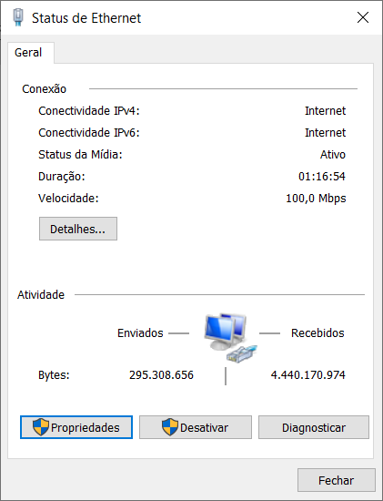

Please solve this puzzle so we know you are a real person
Start Puzzle
Match the number of rocks with the number on the left (1 of 1)
Next time make sure to match the number of rocks with the number on the left
That was not quite right.
- We encountered an unexpected error. Please try again later. If this issue continues, please open a ticket at https://sitehelp.microsoft.com.

Encontramos um erro inesperado. Por favor, tente novamente mais tarde. Se o problema persistir, abra um ticket em https://sitehelp.microsoft.com.

